**77-101: University Seminar**

**Academic Advising Preparation**

***Goal:***

This assignment is designed to encourage you to consider the courses you will need to take next semester, brainstorm questions you can ask your primary academic advisor to help you plan for your academic success, and enhance your utilization of CatPAWS.

***Instructions:***

Complete the worksheet on the following page. Upload the assignment by the due date and be ready to access the document when you meet with your primary academic advisor.

**Academic Advisement Preparation Sheet**

|  |  |  |
| --- | --- | --- |
| **Name:** | Brianna Heredia | |
| **Your major or meta-major:** | | Digital Media: Visual Imaging |

**Step 1: Who is your primary academic advisor?**

* Login to your [CatPAWS](https://ssb.nwmissouri.edu/pls/PRODDAD/twbkwbis.P_GenMenu?name=homepage) account

(User ID is your 919# | PIN may differ from Northwest email/computer login)

* Click on **Registration**
  + View your primary academic advisor by clicking on **Student Records/Advisor Information**
  + Advisor information is also available through Northwest Success 360 and your at the top of your degree audit

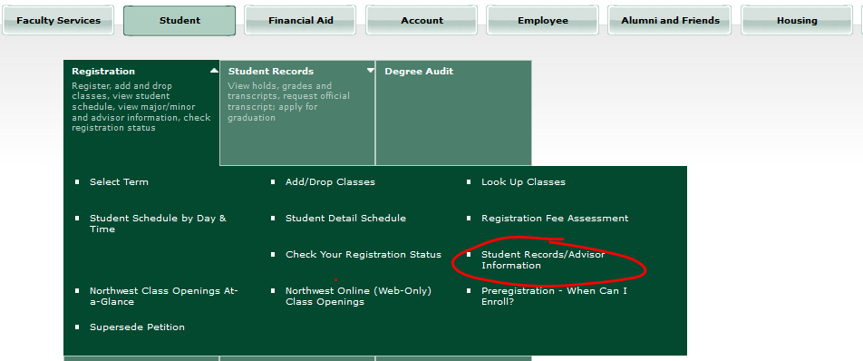

*Answer the following questions:*

|  |  |
| --- | --- |
| **Who is your primary academic advisor?** | Amber T. Hurd |
| **What is the role of your primary academic advisor?**  Primary academic advisors will:   * assist you with course selection and student registration * help connect you with campus resources * introduce you to profession-based experiences to support your major | |
| **Use the** [**Snipping Tool**](https://www.youtube.com/watch?v=gOXS10hT-No) **to add a screenshot of your NW Success 360 appointment with your primary academic advisor.** |  |

**Step 2: When are you able to enroll in next semester’s classes?**

To answer this question, you’ll first need to confirm the number of college credit hours you have earned – not including the credits you are currently taking. Follow these steps to confirm this number:

* Switch to **Student Records** in CatPAWS
  + Select Academic Transcript
* Select the **Academic Transcript** link.

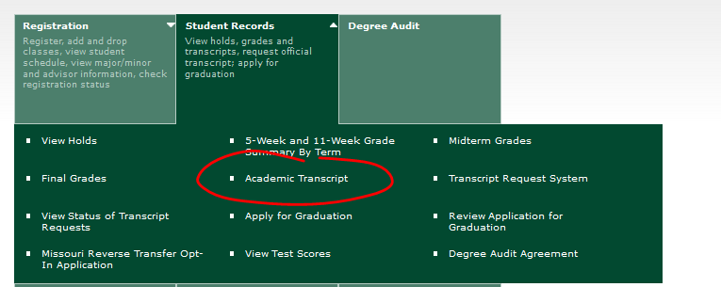

* Select **all transcript levels** and **web** and click submit

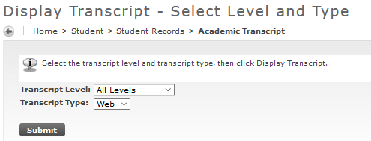

* Scroll to the bottom and identify your overall number under the **Earned Hours** column.

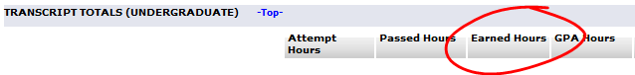

|  |  |
| --- | --- |
| **How many college credit hours have you earned?** | 3.00 |

* Go back to **Registration** and click on **Preregistration-When Can I Enroll?**

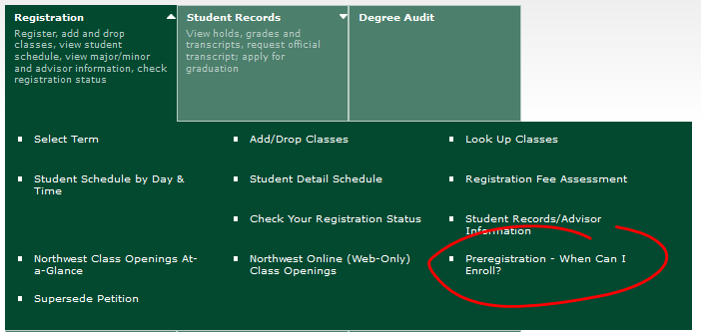

* Locate the date you register based on the number of earned college credit hours

|  |  |
| --- | --- |
| **When are you able to enroll in next semester’s classes?** | November 13 |

* Alternative method: look at your degree audit and subtract the number of credit hours for which you are currently enrolled from the credits applied.



**Step 3: How do you know what courses to take?**

Your primary academic advisor will have some thoughts, but there are three resources you can use to plan for your meeting with your primary academic advisor:

1. Access your **Degree Audit** through CatPaws
2. The Student SuccessCenterprovides [**Four-Year Plans**](https://www.nwmissouri.edu/advisementassistance/4yearplan.htm) online
3. Review previous choices in the , Explore the Northwest Core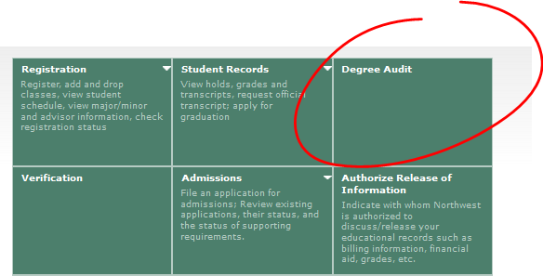

**Step 4: How do you know what courses are being offered?**

There are two ways to learn what courses are being offered this semester:

1. Access your **Degree Audit** through CatPAWS to view course choices specific to your degree. **Click on a** **course number** to read the course description, note prerequisite courses, and view scheduled offerings.

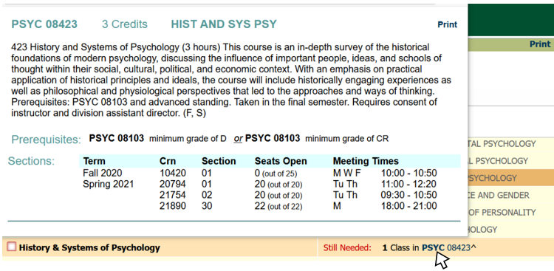

**Course sections offered; record CRN and**

**Meeting Times**

**Indicates the semester(s) this course is offered**

1. Access **Class Openings At-a-Glance** through CatPAWS

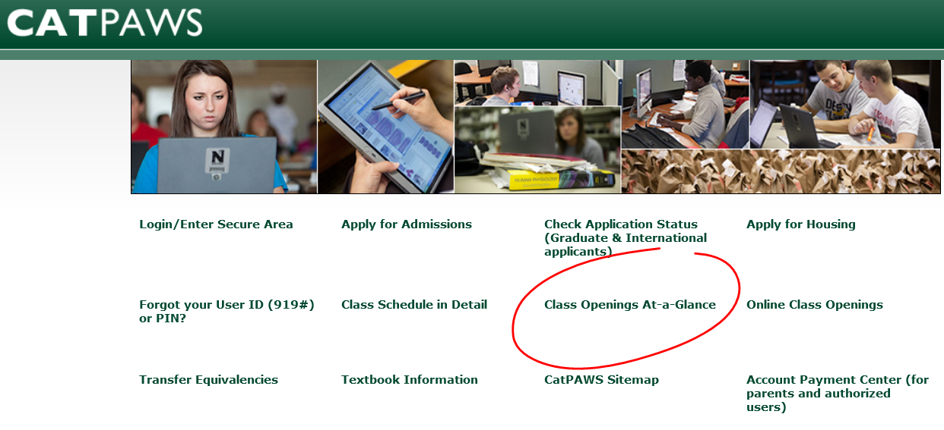

This is the only way to view instructor names and special messages which may include enrollment instructions, materials needed, etc.





**Step 5: Plan your class schedule**

Use the table below to plan the courses you wish to enroll in for the spring semester – including the role of the course in your education. Courses fall into the following categories:

* Northwest Core requirement: general education courses
* Major or minor requirement: courses specific to your degree
* Electives: courses you may be exploring for a potential major or minor

Questions to consider when planning your schedule:

* When is your optimal time for learning?
* Will you schedule breaks between classes to organize notes or start homework?
* Is it easy to travel from one class to another if you schedule them back to back?
* Which courses required by your major or minor offer the fewest number of sections? Which courses are only offered in the fall or spring? *Hint: you’ll want to plan your schedule around these courses.*
* Will you record information for multiple sections of a course in case the section you want fills up? *Hint: this will keep you from looking everything up again later*

Identify a total of **nine** courses. You will not enroll in all nine, as some sections may fill up early.

|  |  |  |  |  |  |
| --- | --- | --- | --- | --- | --- |
| Course Name | Credit Hours | Course Number | CRN | Meeting Times | Northwest Core, Major, Minor, Elective |
| 1. Comp II | 3 | 10112 | 21490 | MWF 9-10 | Northwest Core |
| 1. General Bio | 3 | 04102 | 20167 | TR 9:30-11 | Northwest Core |
| 1. General Bio Lab | 1 | 04103 | 20173 | T 4-6 | Northwest Core |
| 1. General Psych | 3 | 08103 | 20122 | MWF web | Northwest Core |
| 1. Life Drawing | 3 | 13221 | 20691 | TR 2-3:30 | Major |
| 1. Painting | 3 | 13240 | 20259 | MW 10-12 | Major |
| 1. General Earth Science | 3 | 27114 | 20339 | MWF 10-11 | Northwest Core |
| 1. Spanish | 3 | 14141 | 21492 | MWF 1-2 | Northwest Core |
| 1. Computer Graphics I | 3 | 13292 | 21493 | MW 8-9:20 | Major |

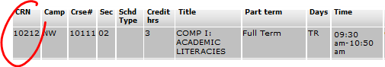**Important note:** The CRN, or Course Reference Number, is specific to a specific section of a course. The course number for a section 2 of English 10-111 might have a CRN of 10212 for the 9:30 am section.

**Step 6: Make the most of your meeting with your primary academic advisor**

Your primary academic advisor will supply you with your ALT PIN, which is a passcode used to enroll in classes through CatPAWS. Your ALT PIN will be different every semester.

|  |  |
| --- | --- |
| **ALT PIN provided**  **by your primary academic advisor:\*** | **NBBYGC** |

*\*You may leave this blank if your instructor requires you to*

*turn this assignment in prior to your advising appointment.*

Use the space below to write at least three questions you will ask your primary academic advisor during your advising meeting. Use the following topics to get you started:

* What questions do you have about courses you are considering taking in the spring?
* Should you supersede, or retake, any courses where you may earn a “C”, “D” or “F” this semester?
* Should you review requirements for your major or minor?
* How should your long-term goals impact your four-year plan?
* Do you fully understand your four-year plan?
* Are you interested in co-curricular activities?

|  |  |
| --- | --- |
| Question 1 | Are there courses that would translate better if I decided to switch majors? |

|  |  |
| --- | --- |
| Question 2 | How many art classes should I take during a single semester? |

|  |  |
| --- | --- |
| Question 3 | Would it be beneficial for me to apply to the honor roll? |

**Step 7: Enroll in next semester’s classes**

Once your registration date opens, you will log in to CatPAWS, select the Registration tab, then click **Add/Drop Courses**. Select Spring 2021 Term, click submit, and enter your ALT PIN (case sensitive).

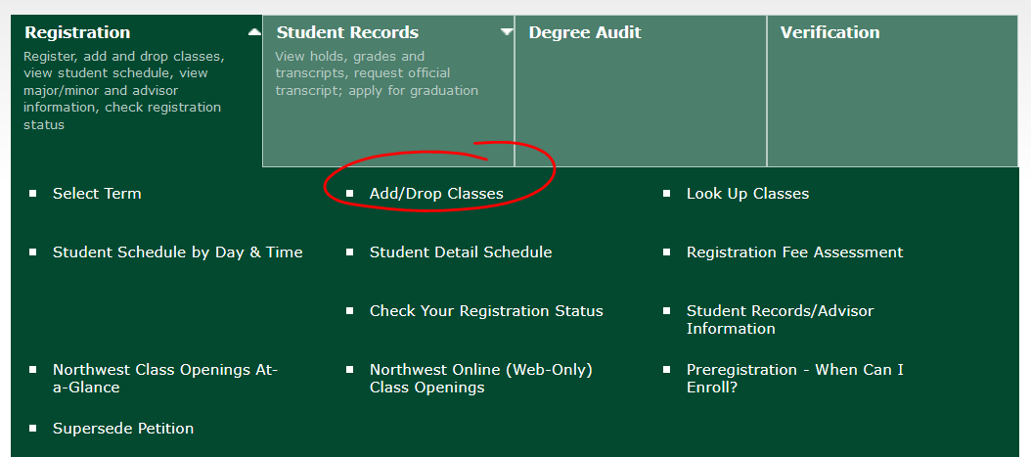

Visit the Office of the Registrar’s [Registration and Verification](https://www.nwmissouri.edu/registrar/register.htm) page for questions about *superseding* or *waitlisting* a course.

After you finish enrolling, double check your class schedule by clicking on **Student Schedule by Day & Time** in CatPAWS. Enter a date that occurs during the next semester on the next screen.

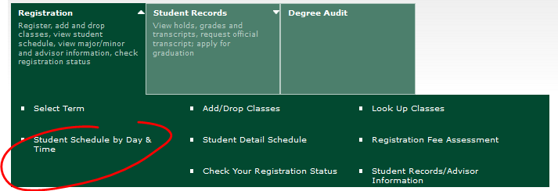

*Hint: the Registrar’s Office, 2nd floor Administration building, will print you an easy-to-view copy of your schedule-just ask!*